Solar tuk-tuk journey halted by robbery in France
- 7 September 2016

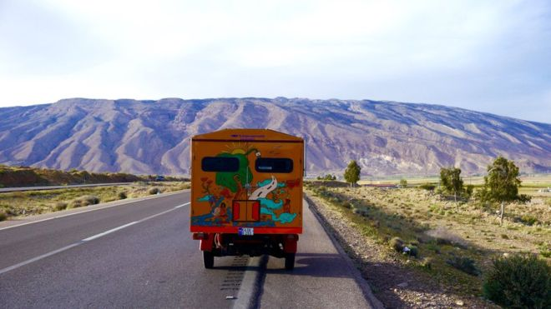

Image copyright Naveen Rabelli Image caption Mr Rabelli modified the diesel tuk-tuk to run on electric and solar power

An engineer travelling from India to Britain in a self-modified solar and electric-powered tuk-tuk has been robbed in France, derailing the final leg of a seven-month journey.
Naveen Rabelli had his passport and wallet stolen from his parked tuk-tuk in Sarcelles while using a bathroom.
He is waiting for a new passport to cross the English Channel and finish his journey at Buckingham Palace.
Mr Rabelli is trying to draw attention to renewable energy.
"I have been on road for seven months now, and have been dreaming to get to [the] UK. For four years I have been preparing for this," he told the BBC.
"It really sucks to have lost my passport and 1,000 euros" while en route to Calais to take a ferry to the UK, he said
Mr Rabelli has been helped by strangers along his journey, which took him through Iran, Turkey, Greece, Bulgaria, Serbia, Austria, Germany and Switzerland.
He sleeps in his auto-rickshaw when not offered accommodation and managed to save up money along the way.
"People donated. I sold olive oil in [a] market, I sold my postcards, I sold Greek liquor," he said.
The 35-year-old, an Australian national and Indian resident, has worked for Mahindra Reva, an Indian electric car company.
He bought the diesel tuk-tuk for $1,500 (£1,120) and spent $11,500 customising it. It has a top speed of 60km/h (37 mph) and is powered by both electricity and solar power.
The vehicle has a bed and a solar cooker.

Answer the questions
- What was stolen? What was he doing when it was stolen?
- Does Rabelli´s tuk-tuk run on diesel?
- Why is he on this journey?
- Where did he get his money from?
- How much money has he spent on the tuk-tuk?
Choose 5-10 words/phrases, copy and translate them in your notebook. (e.g. tuk-tuk, to halt, journey, to draw attention to, a ferry, stranger, accommodation, to save up money, vehicle, ....)

