Book review
Hello, our task today is to learn how to write a book review. Keep in mind a book review is not a plot summary, that’s just one part of it.
Your task is to write your own review, either of a book you’ve read or are reading now. It can be a book you’ve read in Slovak, English, Kazakh language.
The review must contain two parts:
- general
- personal
In the general one include:
- What book is it? Basic facts: genre, who it was written by, when it was published, has it been made into a film?, and other interesting facts (popularity-related, e.g. number of copies sold, languages it has been translated into, etc.)
- Plot summary: Where is the story set? Who are the main characters? Write a brief description of the plot – two important things:
  - use Present Simple to describe the plot (Mark lives in a small village. One day he decides to go to the city to see what the life is like there... )
  - don’t give away the ending. A review MUST NOT say how the story ends.
In the personal one include:
- Aspects of the book you particularly liked: characters you enjoyed/identified with, descriptions of nature/characters, the plot (fast-moving, gripping etc.), the dialogues, the idea/the message of the book, the writing style of the author, the information you learnt, how the book changed your perspective, thinking, what you realized etc. etc.
- Aspects of the book you didn’t like.
- Overall opinion. Do you recommend the book? If yes, to what readers.
IMPORTANT: The plot description can take up max. 50 % of the whole review.
You will get a mark for the review, it can be a 4 or even a 5 if you copy a review from the Internet or if it’s just a plot description.
Below you’ll find some useful phrases and an example review:
Useful phrases:
- It’s the story of...
- It was written by...
- It’s set in (place)
- It’s a (type of story)
- The main character is (name)
- A film was made (of the book, starring (actor..) )
- There’s a twist at the end.
- I like the book because...
- I identified with.. (a character)
- What I liked most was...
- What I found a bit boring was...
- I would definitely/thoroughly recommend it.

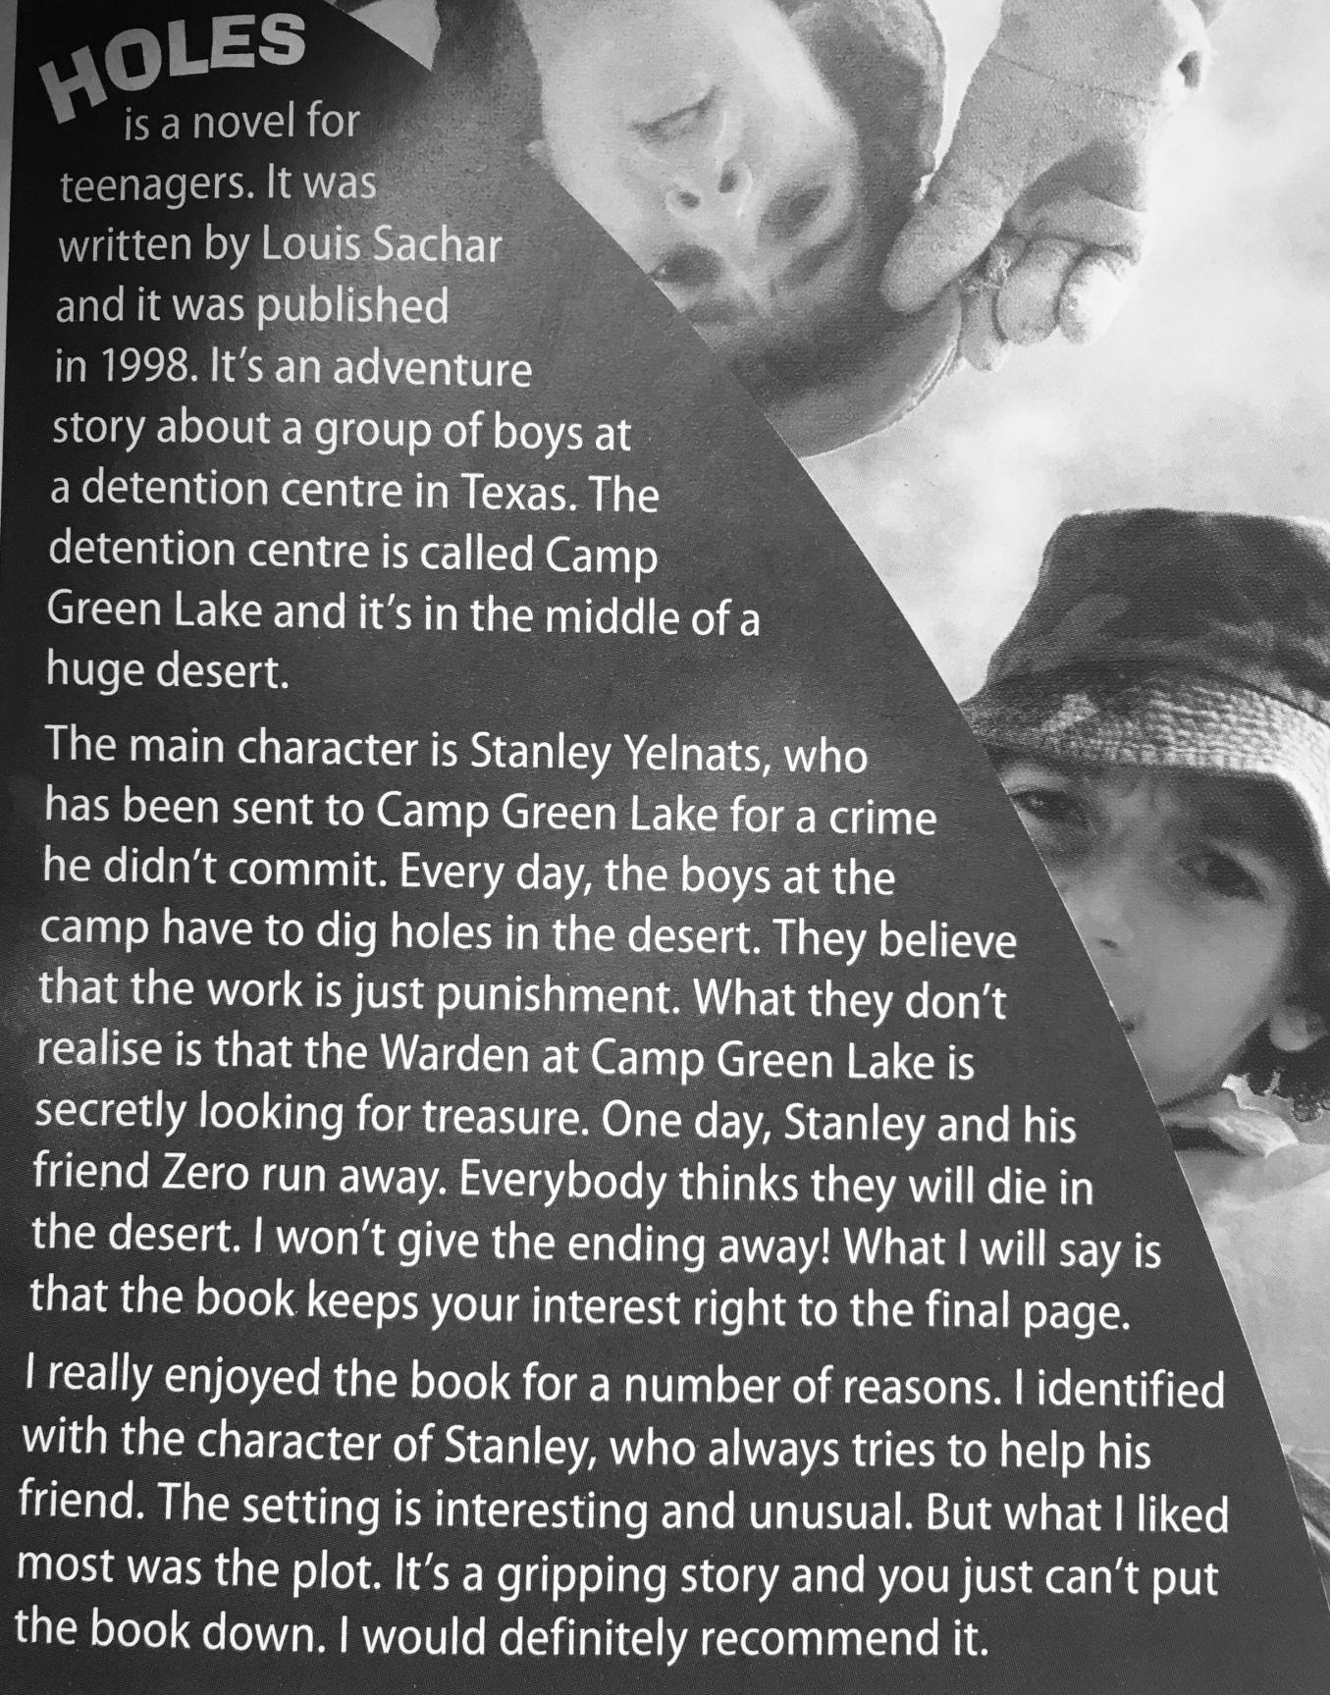
Example review

Send your review to englishsosban@gmail.com by Thursday 21st May (if you haven’t read a book recently, 2 weeks is enough time to read one a write a review). It should have 160-220 words. Remember to divide the review into paragraphs.
You can find some good book tips (the books are not too long) here:
https://mercatornet.com/101-books-millennials-must-read-before-they-die/23382/

